This document explains the process for deleting a single applicant from the e-Recruitment system following an individual request from the applicant, normally via incident management.

Table of Contents

Introduction 1
Restrictions 1
1. Check vacancies applied for 2
2. Updating the applicant status 3
3. Clearing down the applicant record(s) 4
4. Vacancies where the applicant statuses are not complete 6
5. Clearing an applicant portal account where no applications have been submitted. 6

Knowledge Article: Applicant Cleardown Knowledge Article

Other Related Documents

HOW TO manage the bulk applicant clear down process.docx

Deleting an applicant account from the applicant portal where no applications have been submitted

Restrictions
There is a limit to what we are able to clear down. Applications must be retained for a period of six months after an appointment has been confirmed or it has been confirmed that no appointment has been/will be made for that vacancy. These timescales have been confirmed by Anne Harkness.

If an application cannot be cleared down because it is less than six months from the final status date of the vacancy the HRIS Support Centre have a standard email to send to the applicant. For further details refer to the related Knowledge Article.

Process steps

Check vacancies applied for

Navigate to Recruitment > Recruitment Enquiries > Applicant Detail

For each vacancy that the applicant has applied for you must check that all applicant statuses are in a “final state” (i.e. one of the ‘Rejected’ statuses, one of the ‘Successful’ statuses or ‘Offer Refused ‘, ‘Withdrawn’, ‘Standby’ etc) and that the date of the final applicant status is at least 6 months prior to today’s date.

The only exception to this is if the vacancy is in TSS. In this case you must check that the status for the applicant you are clearing down is at least 6 months before today’s date.

  - Search for and open the applicant record.

  - Click on Vacancy Detail from the select detail menu.

The Applicant Maintenance window opens:

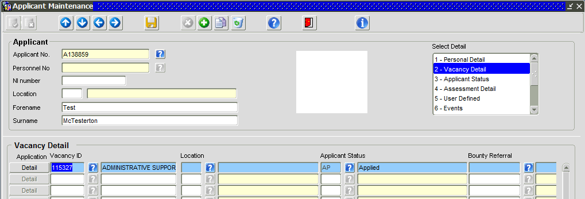

  - Make a note of the all the vacancies that the individual has applied for.

Navigate to Recruitment > Recruitment Enquiries > Vacancy Detail

  - Go the Applicant Status screen and check the status of ALL applicants on each vacancy (excluding TSS vacancies).
If any of the applicants have a status that is not a “final” status (e.g. ‘Applied’, ‘Shortlisted’, ‘Invited to Interview 1’, ‘Offer Made’, ‘Preferred Candidate’, ‘Request References’ etc) go to section 4:

If ALL applicants have one of the following statuses, ‘Rejected’ statuses, one of the ‘Successful’ statuses or ‘Offer Refused ‘, ‘Withdrawn’, ‘Standby’ etc. continue to section 2.

Updating the applicant status

Navigate to Recruitment > Recruitment Maintenance > Vacancy Detail

In order to be able to run the clear down process you first need to change the applicant status to ‘Z-HRIS Support Centre Use Only’.

You must also delete the merged pack on each vacancy as it will contain the application submitted by the applicant you are clearing down.

For each vacancy that the applicant has applied for, follow the steps below:

  - Open the vacancy and go to the Applicant status screen.

  - Check the latest “status date” of all applicants.

If the latest applicant status date is less than six months ago, make a diary note to revisit the vacancy after 6 months have elapsed.

If the latest applicant status date is more than six months ago, continue from step 2.3 onwards.

  - Click on the Applicant ID or Name to select the applicant you want to update.

  - From the drop down list under ‘Applicant status’ choose “Z-HRIS Support Centre Use Only” and SAVE.

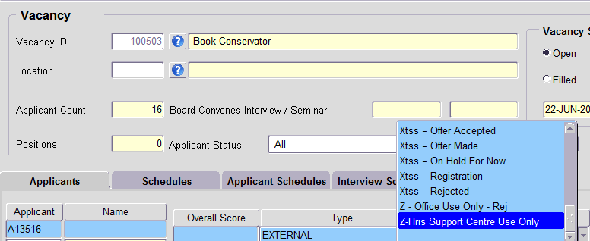

  - The Applicant Status and Status Date are now updated. Click on the Generate Applications button. The ‘Generate Applications’ window opens:

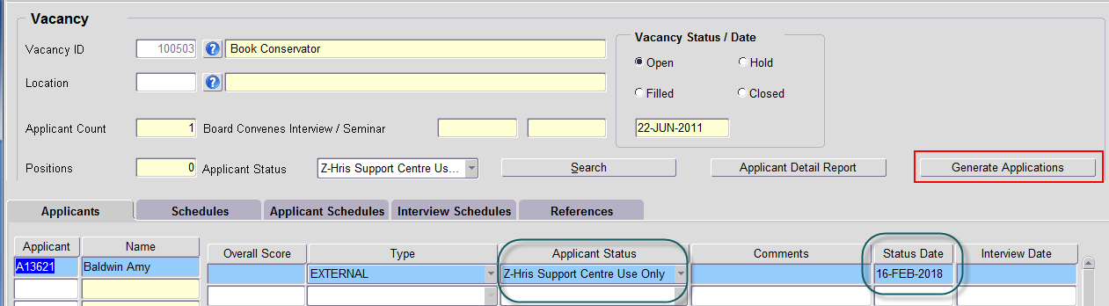

  - Click on the Delete Merged Application button.

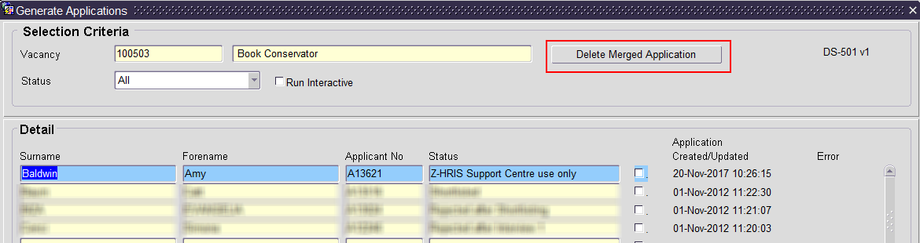

Clearing down the applicant record(s)

Once the steps in Section 2 have been completed for all applicable vacancies, navigate to:

Recruitment > Recruitment Maintenance > Applicant Clear Down

  - Enter the date/s that you changed the Applicant Status(es) into the Start Date and End Date fields.

 | NB: if you made the changes over two or more days, enter the earliest date into the Start Date field and the latest date in the End Date field.

  - Enter/select ZSUP in the “Applicant Status” field:

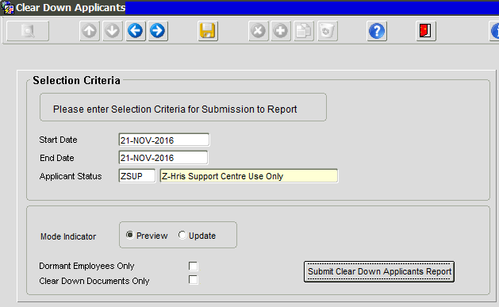

  - Ensure that the Mode Indicator is set to Preview and click the “Submit Clear Down Applicants Report” button.

The Preview report will open in a new window showing the applicant(s) that will be cleared down and the vacancy ID/s. Note that the Mode of Operation = Preview

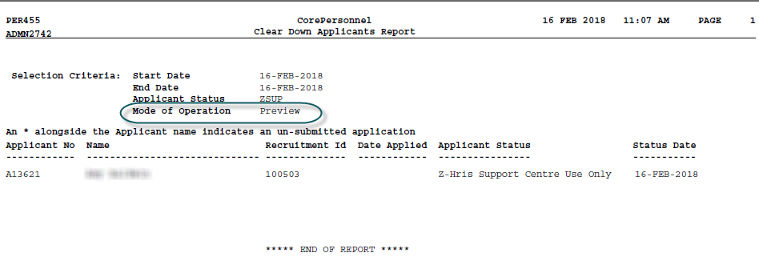

  - Check that the correct applicant(s) and vacancy(ies) are returned in the report.

  - If the expected details are shown in the report, change the mode indicator to Update and click the Submit Clear Down Applicants Report button.

A new report will open in a new window showing the applicant records that have been cleared down. Note that the Mode of Operation = Update:

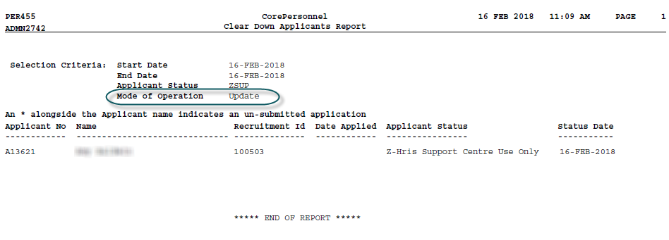

Vacancies where the applicant statuses are not complete

If the applicant statuses on any of the vacancies are not complete the HRIS Support Centre will need to contact the recruiting Department(s).

 | NB: If the applicant statuses on any of the vacancies are not complete the HRIS Support Centre will need to contact the Department(s).

  - If the recruitment process is complete, the department(s) must update the applicant statuses for the vacancy(ies) to their final statuses as defined in section 1.4.

  - If the department confirms that the recruitment process is still underway for the vacancy(ies) you will need to wait until the applicant statuses have all been update to a final statuses as defined in section 1.4.

 | NB: In both cases you must wait for six months after the final “status date” to remove the application for that vacancy.

Clearing an applicant portal account where no applications have been submitted.

It is not currently possible to clear down an applicant account in the Portal if they have not submitted any applications. We have raised this with Core but they also are unable to action this.
A workaround has therefore been agreed that the 1st line support centre will carry out.

